PCB 4674 Evolution 27-29 June 2016
Lab # 6: Quantitative Genetics

QUANTITATIVE GENETICS
Reference chapters (in textbook): Ch. 7

This is what my packet was missing. Turning it in on Canvas.

5. Holly-Goes are cute animals that live right under our noses. They live underground and the only way we came to know about their existence in the first place is because they stink. The intensity of smell can be measured with an olfactometer and each smell has specific compounds that allow the identification of related individuals.
The following table shows the intensities of smell of families of Holly-Goes. These reproduced and had babies during an extremely dry season.

Midparent | Midoffspring
0.97 | 0.8
0.76 | 0.6
2.70 | 2.3
0.01 | 0.0
0.29 | 0.2
3.40 | 2.8
1.19 | 1.0
3.41 | 2.8
0.98 | 0.8
2.66 | 2.2
0.40 | 0.3

5.1. What is the narrow sense heritability of stinkiness in the Holly-Goes?
“Narrow sense heritability is the proportion of total phenotypic variation that is due to the additive effects of genes. This component of variation is important because it is the only variation that natural selection can act on.”(www.evotutor.org/Selection/Sl4A.html)
Midparent | Midoffspring
0.01 | 0
0.29 | 0.2
0.4 | 0.3
0.76 | 0.6
0.97 | 0.8
0.98 | 0.8
1.19 | 1
2.66 | 2.2
2.7 | 2.3
3.4 | 2.8
3.41 | 2.8
Using parent-offspring regression:
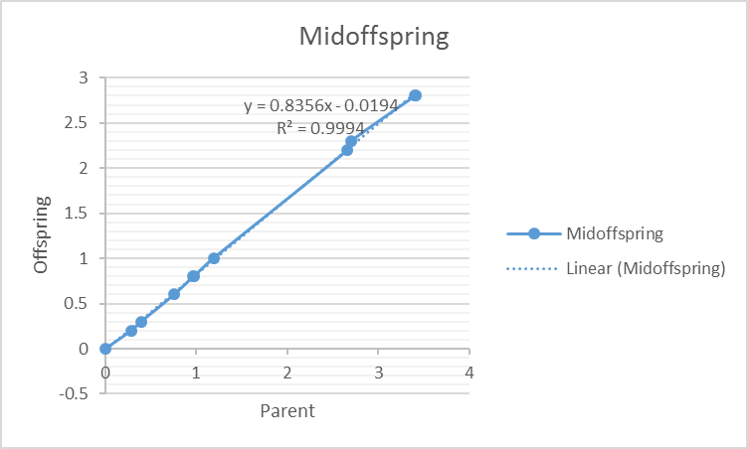

R2= 0.99

5.2. After the dry season, a normal season came. The rain increased the stinkiness so severely that even the Holly-Goes couldn’t stand to be around each other. This led to the death of the 3 smelliest individuals in the offspring group (the ones with the highest intensity of smell) due to loneliness. Predict the mean phenotypic value of the population of the next (F2) generation.
Since most of the individuals are very smelly, they likely hood that they will reproduce is low. The smelliest individuals would mate with not so smelly individuals, making an average individual smelly phenotype. During this normal season, it would be expected that there will be less reproduction and that their offspring will me medium smelly.

6. Describe how you could use a card game to simulate variation due to a genotype by environment interaction. How would this GxE affect heritability?

A card game could be used to simulate variation due to genotype by environmental interaction. You could grad cards that indicate the genotype of each parent. Then you could apply another card for each parent to see how gravely the environmental factors impact them. From there, the parents with the highest “fitness” will be able to reproduce. The genotype and environmental factors would affect heritability because some individuals would be able to reproduce but if there was a catastrophic event, they might die so then they will not be able to reproduce.

7. What are epistatic effects? How do they affect heritability? Why? How is this similar to the reason dominance effects affect heritability?

